DEPARTMENT OF COMPUTER SCIENCE AND ENGINEERING

Subject: COMPUTER NETWORKS Subject Code: CS T52

UNIT-III

Network layer – design issues – Routing algorithms - The Optimality Principle - Shortest Path Algorithm – Flooding - Distance Vector Routing - Link State Routing - Hierarchical Routing - Broadcast Routing - Multicast Routing Congestion Control – Approaches - Traffic-Aware Routing - Admission Control - Traffic Throttling - Load Shedding – Internetworking - Tunneling - Internetwork Routing - Packet Fragmentation - IP v4 - IP Addresses – IPv6 - Internet Control Protocols – OSPF - BGP

2 MARKS
- What are the services offered by network layer?
  - Logical addressing
  - Routing
- What are the methods of packet switching?
- Virtual Circuit approach.
- Datagram approach
- Differentiate virtual circuit and datagram’s.
VC is connection oriented and datagram is connectionless.
- What is meant by virtual path?
Virtual path is a set of connections between two switches.
- What is meant by routing algorithm?
The algorithm that manages routing tables and makes the routing decisions is called routing algorithm.
- What are the desirable properties of a routing algorithms?
- Correctness
- Simplicity
- Robustness
- Stability
- Fairness
- Optimality
- What are the types of routing algorithms?
- Non adaptive routing algorithm
- Adaptive routing algorithm
- Distinguish between adaptive and non adaptive routing algorithms.
Non adaptive Routing:
Once a pathway to a destination has been selected the router sends all packets for that destination along that one route. The routing decisions are not based on the condition or topology of the networks.
Adaptive Routing:
Router may select a new route for each packet.(even packets belonging to the same transmission).The routing decisions are based on the condition or topology of the networks.
- What are the metrics used by routing protocols?
Path length, reliability, delay, bandwidth, load and communication cost.
- What is static routing?
Static routing is a form of routing that occurs when a router uses a manually-configured routing entry, rather than information from a dynamic routing traffic.
- What is dynamic routing?
Dynamic routing, also called adaptive routing, describes the capability of a system, through which routes are characterized by their destination, to alter the path that the route takes through the system in response to a change in conditions.
- What is adaptive routing algorithm?
Adaptive routing algorithms change their routing decisions to reflect changes in the topology and usually the traffic as well. Distance vector and link state are examples of this.
- Why is adaptive routing superior to non adaptive routing?
Adaptive routing is superior to non adaptive routing because adaptive routing may select a new route for each packet in response to change in condition and topology of the networks.
- What is the router’s role in controlling the packet lifetime?
As packet is generated, each packet is market with a lifetime; usually the number of hops that are allowed before a packet is considered lost and, accordingly destroyed. As each router encounters the packet subtracts 1 from the total before passing it on. When the lifetime total reaches 0, the packet is destroyed.
- In routing what does the term SHORTEST mean?
The term Shortest mean the combination of many factors including shortest, cheapest fastest most reliable and so on.
- Define flooding?
Flooding means that a router sends its information to all of its neighbors and all of its output ports
- What are the advantages of flooding?
  - Simple
  - Needs no network information or routing tables
  - Robust for failure prone networks.
  - Shortest path is always found.
- What are the most popular routing algorithms?
  - Distance Vector routing
  - Link State routing
  - Hierarchical routing
- What is Distance vector routing?
Distance vector routing is a simple routing protocol used in packet-switched networks that utilizes distance to decide the best packet forwarding path. Distance is typically represented by the hop count
- What are the three main elements of distance vector algorithms?
    - Knowledge about the entire autonomous system.
    - Routing only to neighbours
    - Information sharing at regular intervals
- What are the main disadvantages of distance vector routing?
- Split horizon
- Count to infinity problem
- What is Link state routing?
Link-state routing protocols, such as OSPF and IS-IS, create a topology of the network and place themselves at the root of the tree. Link-state protocols implement an algorithm called the shortest path first (SPF, also known as Dijkstra's Algorithm) to determine the path to a remote destination.
- What are the three main elements of Link state routing?
- Knowledge about the neighborhood.
- Sharing with every other network.
- Information sharing when there is a change.
- What algorithm does link state routing use to calculate the routing tables.
- Dijkstra algorithm is used to calculate the routing table.
- What is Hierarchical routing?
Hierarchical routing is a method of routing in networks that is based on hierarchical addressing.
- Explain Multicasting.
A form of addressing in which a set of computer is assigned one address, a copy of any datagram sent to the address is delivered to each of the computers in the set.
- Define the term broadcasting.
A form of delivery in which one copy of a packet is delivered to each computer on a network.
- Why is it that in a broadcast network, the network layer is often thin or even nonexistent?
Network layer is responsible for host to host delivery and for routing the packets through the routers or switches. In broadcast there is no need of addressing the packets, routing and address verification.
- What is congestion control?
Congestion control is a global issue – involves every router and host within the subnet. Flow control – scope is point-to-point; involves just sender and receiver.
- What is congestion? Why congestion occurs?
  - In a packet switching network, packets are introduced in the nodes (i.e. offered load), and the nodes in-turn forward the packets (i.e. throughput) into the network. When the “offered load” crosses certain limit, then there is a sharp fall in the throughput. This phenomenon is known as congestion.

  - In every node of a packet switching network, queues (or buffers) are maintained to receive and transmit packets (store/forward network) . Due to busty nature of the network traffic there may be situations where there is overflow of the queues. As a result there will be re-transmission of several packets, which further increases the network traffic. This finally leads to congestion
- What are the two basic mechanisms of congestion control?
The two basic mechanisms of congestion control are:
  - One is preventive, where precautions are taken so that congestion can not occur.

  - Another is recovery from congestion, when congestion has already taken place
- How congestion control is performed by leaky bucket algorithm?
- In leaky bucket algorithm, a buffering mechanism is introduced between the host computer and the network in order to regulate the flow of traffic. Busty traffic are generated by the host computer and introduced in the network by leaky bucket mechanism in the following manner

  - Packets are introduced in the network in one per tick

  - In case of buffer overflow packets are discarded
- In what way token bucket algorithm is superior to leaky bucket algorithm?
The leaky bucket algorithm controls the rate at which the packets are introduced in the network, but it is very conservative in nature. Some flexibility is introduced in token bucket algorithm. In token bucket algorithm tokens are generated at each tick (up to certain limit). For an incoming packet to be transmitted it must capture a token and the transmission takes place at the same rate. Hence some of the busty packets are transmitted at the same rate if tokens are available and thus introduces some amount of flexibility in the system. This also improves the performance.
- What is choke packet? How is it used for congestion control?
Choke packet scheme is a close loop mechanism where each link is monitored to examine how much utilization is taking place. If the utilization goes beyond a certain threshold limit, the link goes to a warning and a special packet, called choke packet is sent to the source. On receiving the choke packet, the source reduced the traffic in order to avoid congestion.

The congestion control in the choke packet scheme can be monitored in the following manner.

- Each link is monitored to estimate the level of utilization.
- If the utilization crosses a certain threshold limit, the link goes to a warning state and a choke packet is send to the source.

- On receiving the choke packet, the source reduces the transmitting limit to a certain level (say, by 50%).

- If still warning state persists, more choke packets are sent further reducing the traffic. This continues until the link recovers from the warning state.

- If no further choke packet is received by the source within a time interval, the traffic is increased gradually so that the system doesn’t go to congestion state again.
- What is Admission control?
Admission Control is a validation process in communication systems where a check is performed before a connection is established to see if current resources are sufficient for the proposed connection.
- What is Traffic Throttling or traffic shapping?
Bandwidth throttling is the intentional slowing of Internet service by an Internet service provider. It is a reactive measure employed in communication networks in an apparent attempt to regulate network traffic and minimize bandwidth congestion.
- What is Load Shedding?
Load shedding techniques reduce the load of a system when under severe stress, in the case of network monitoring in order to avoid uncontrolled packet loss.
- What is mean by internetworks?
When two or more networks are connected, they become internetwork or internet. Internetworking is the practice of connecting a computer network with other networks through the use of gateways that provide a common method of routing information packets between the networks. The resulting system of interconnected networks is called an internetwork, or simply an internet.
- Define Tunneling?
Tunneling, also known as "port forwarding," is the transmission of data intended for use only within a private, usually corporate network through a public network in such a way that the routing nodes in the public network are unaware that the transmission is part of a private network.
- What is internetwork routing?
The number assigned to a single network in an internetwork. Network addresses are used by hosts and routers when routing a packet from a source to a destination in an internetwork. Host address. Also known as a host ID or a node ID.
- What is packet fragmentation?
The Internet Protocol (IP) implements datagram fragmentation, breaking it into smaller pieces, so that packets may be formed that can pass through a link with a smaller maximum transmission unit (MTU) than the original datagram size.
- What is IPV4?
Internet Protocol version 4 (IPv4) is the fourth version in the development of the Internet Protocol (IP). It is one of the core protocols of standards-based internetworking methods in the Internet, and was the first version deployed for production in the ARPANET in 1983.
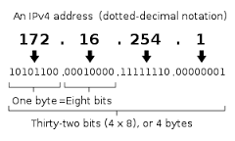
- What is Network address translation (NAT) ?
Network address translation (NAT) is a methodology of remapping one IP address space into another by modifying network address information in Internet Protocol (IP) datagram packet headers while they are in transit across a traffic routing device.
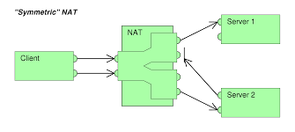
- What is IPV6?
IPv6 is the Internet's next-generation protocol, designed to replace the current Internet Protocol, IP Version 4. In order to communicate over the Internet, computers and other devices must have sender and receiver addresses. These numeric addresses are known as Internet Protocol addresses.
- What is an Internet Protocol (IP)?
The protocol that defines both the format of packets used on a TCP/IP internet and the mechanisms for routing a packet to its destination.
- What is an IP address?
An IP address is a 32 - bit address that uniquely and universally define the connection of a host or a router to the Internet. The sender must know the IP address of the destination computer before sending a packet.
- What are the categories of IP addresses?
IP addresses were divided into five categories as follows.
- Class A
- Class B
- Class C
- Class D
- Class E
- Discuss the class field in IP address.
If the address is given in binary notation, the first few bits can tell us the class of the address.
- Class A - 0
- Class B - 10
- Class C - 110
- Class D - 1110
- Class E - 1111
When the address is given in dotted decimal notation, then look at the first byte to determine the class of the address..
- Class A - 0 to 127
- Class B – 128 to 191
- Class C – 192 to 223
- Class D – 224 to 239
- Class E – 240 to 255
- What is a host-id and net-id?
Net-id – The portion of the IP address that identifies the network called the netid.
Host-id – The portion of the IP address that identifies the host or router on the network is called the hostid.
- How does a netid differ from a network address?
A network address has both netid and hostid with 0’s for the hostid.
- What is the purpose of subnetting?
- When we divide a network into several subnets, we have three levels of hierarchy.
- The netid is the first level, defines the site.
- The subnetid is the 2nd level, defines the physical subnetwork.
- The hostid is the 3rd level defines the connection of the host to the subnetwork.

- What are the benefits of subnetting a network?
- Reduced network traffic
- Optimized network performance
- Simplified network management
- Facilities spanning large geographical distance.
- Define Masking.
Masking is a process that extracts the address of the physical network from an IP address.
- What is the difference between boundary level masking and non-boundary level masking.
Boundary level Masking:
- If the masking is at the boundary level, the mask numbers are either 255 or 0, finding the subnetwork address is very easy.
Non Boundary level Masking:
- If the masking is not at the boundary level, the mask numbers are not just 255 or 0, finding the subnetwork address involves using the bitwise AND operators.
- What is the class of each of the following addresses?
- 10011101 10001111 11111100 11001111 – Class B
- 11011101 10001111 11111100 11001111 – Class C
- 01111011 10001111 11111100 11001111 – Class A
- 11101011 10001111 11111100 11001111 – Class D
- 11110101 10001111 11111100 11001111 – Class E
- Find the class of each address.
- 4.23.145.90 – Class A
- 227.34.78.7 – Class D
- 246.7.3.8 – Class E
- 29.6.8.4 – Class A
- 198.76.9.23 – Class C
- What is Supernetting?
Supernetting combines several networks into one lager one.
- Identify the class and default subnet mask of the IP address 217.65.10.7.
It belongs to class C.
Default subnet mask – 255.255.255.192
- What are the fields present in IP address?
Netid and Hostid.
Netid – portion of the ip address that identifies the network.
Hostid – portion of the ip address that identifies the host or router on the networks.
- What is the time to live field in IP header?
Time to live field is counter used to limit packet lifetimes counts in second and default value is 255 sec.
- Identify the class and default subnet mask of the IP address 217.65.10.7
IP address 217.65.10.7 belongs to class C address and default subnet mask is 255.255.255.0.
- What is internet control Message protocol?
The Internet Control Message Protocol (ICMP) is one of the main protocols of the Internet Protocol Suite. It is used by network devices, like routers, to send error messages indicating, for example, that a requested service is not available or that a host or router could not be reached.
- What is address resolution?
Address resolution is a process of obtaining the physical address of a computer based on its IP address, in order to be able to finally actually transmit the frame or datagrams over the network to which the node belongs.
- What is OSPF?
Open Shortest Path First (OSPF) is a routing protocol for Internet Protocol (IP) networks. It uses a link state routing algorithm and falls into the group of interior routing protocols, operating within a single autonomous system (AS)
- What is BGP?
Border Gateway Protocol (BGP) is a standardized exterior gateway protocol designed to exchange routing and reachability information between autonomous systems (AS) on the Internet. The protocol is often classified as a path vector protocol but is sometimes also classed as a distance-vector routing protocol.

11 MARKS
- Discuss about Design of Network layer
- Store-and-Forward Packet Switching
- Services Provided to the Transport Layer
- Implementation of Connectionless Service
- Implementation of Connection-Oriented Service
- Comparison of Virtual-Circuit and Datagram Subnets

Store-and-Forward Packet Switching
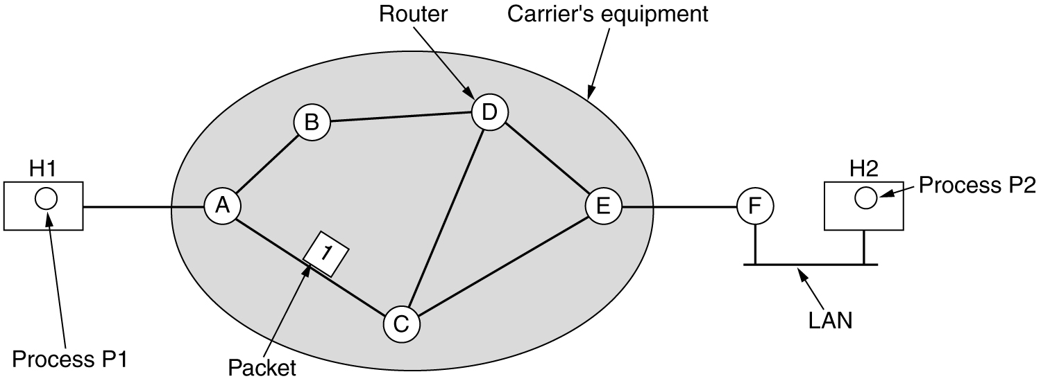

- A host with a packet to send transmits it to the nearest router, either on its own LAN or over a point-to-point link to the carrier.
- The packet is stored there until it has fully arrived so the checksum can be verified. Then it is forwarded to the next router along the path until it reaches the destination host, where it is delivered. This mechanism is store-and-forward packet switching.
Services Provided to the Transport Layer
- The services should be independent of the router technology.
- The transport layer should be shielded from the number, type, and topology of the routers present.
- The network addresses made available to the transport layer should use a uniform numbering plan, even across LANs and WANs.
Implementation of Connectionless Service
- Two different organizations are possible, depending on the type of service offered.
- If connectionless service is offered, packets are injected into the subnet individually and routed independently of each other. No advance setup is needed. In this context, the packets are frequently called datagrams and the subnet is called a datagram subnet.
- If connection-oriented service is used, a path from the source router to the destination router must be established before any data packets can be sent. This connection is called a VC (virtual circuit) and the subnet is called a virtual-circuit subnet.
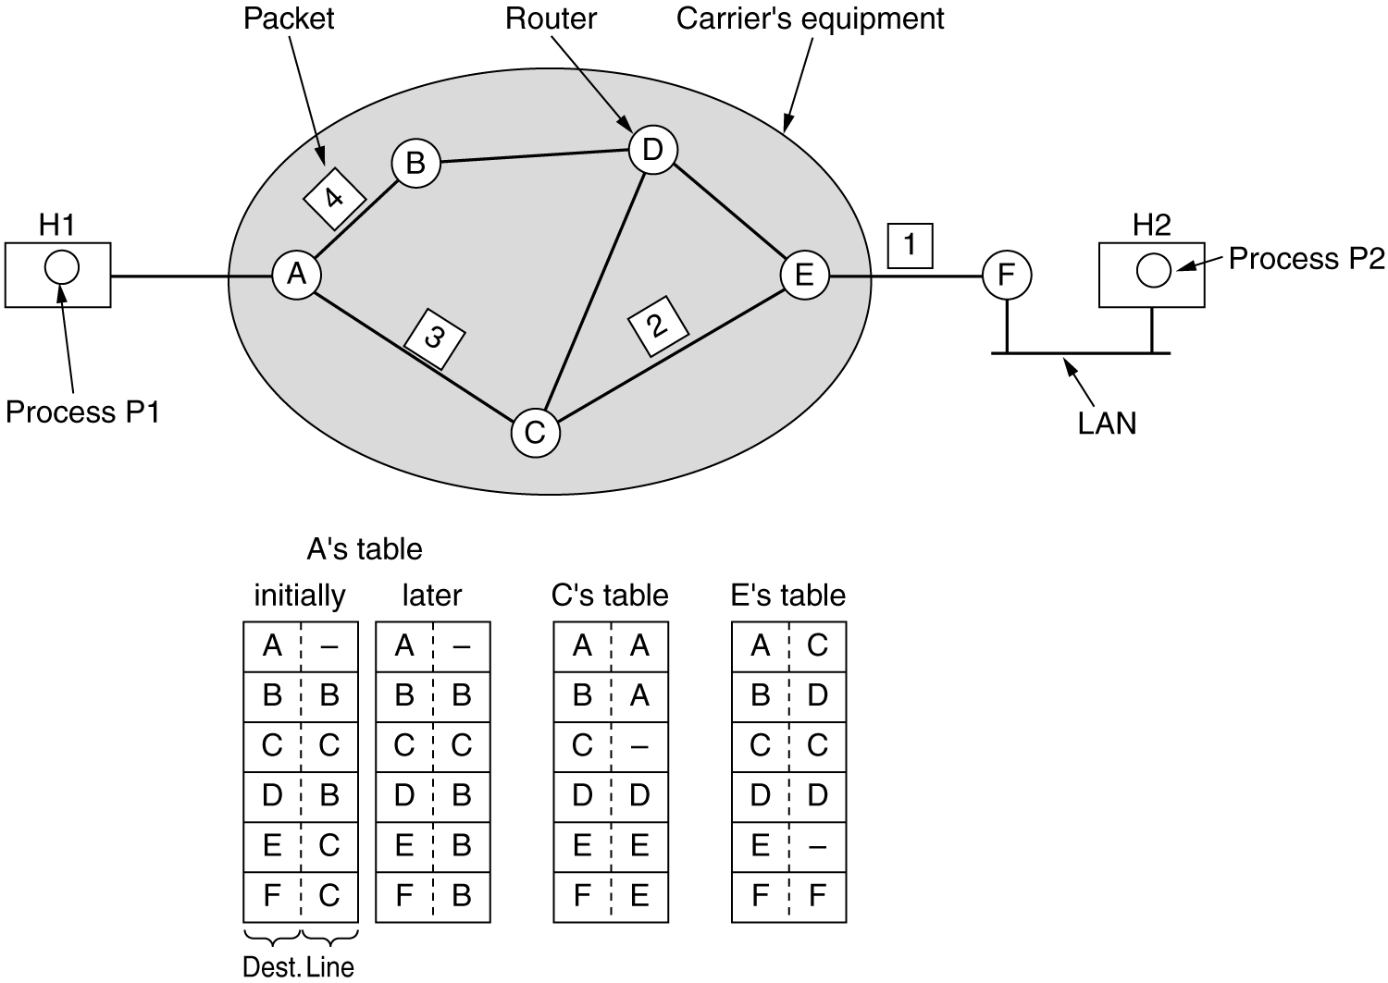

Implementation of Connection-Oriented Service
- For connection-oriented service, we need a virtual-circuit subnet.
- The idea behind virtual circuits is to avoid having to choose a new route for every packet sent. Instead,when a connection is established, a route from the source machine to the destination machine is chosen as part of the connection setup and stored in tables inside the routers. That route is used for all traffic flowing over the connection, exactly the same way that the teleph-one system works. When the connection is released, the virtual circuit is also terminated.
- With connection-oriented service, each packet carries an identifier telling which virtual circuit it belongs to
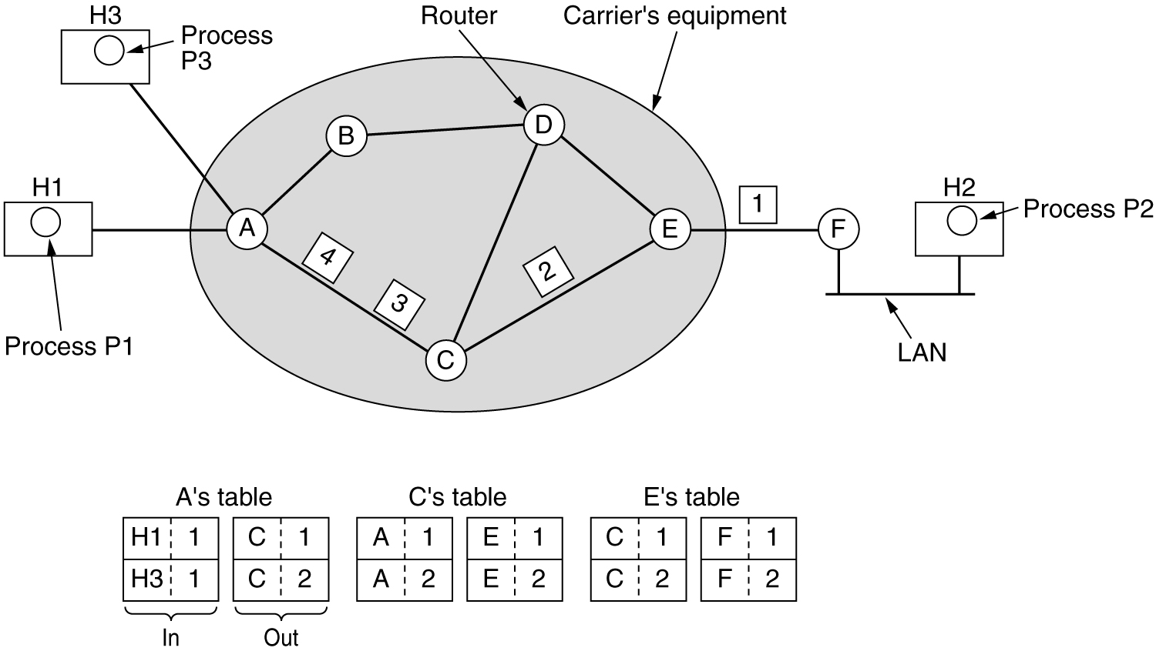
Routing within a virtual-circuit subnet

Comparison of Virtual-Circuit and Datagram Subnets

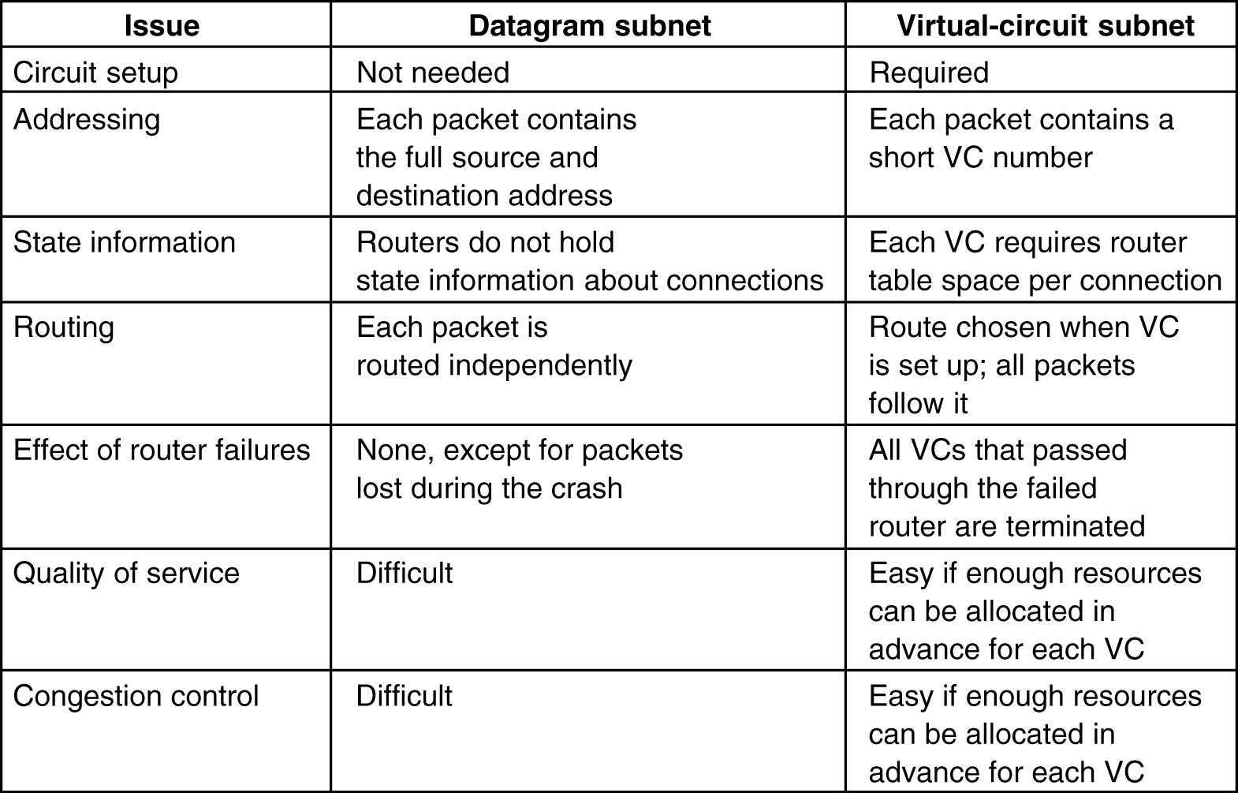
- Inside the subnet, several trade-offs exist between virtual circuits and datagram’s.
- One trade-off is between router memory space and bandwidth.
- Virtual circuits allow packets to contain circuit numbers instead of full destination addresses. If the packets tend to be fairly short, a full destination address in every packet may represent a significant amount of overhead and hence, wasted bandwidth.
- The price paid for using virtual circuits internally is the table space within the routers. Depending upon the relative cost of communication circuits versus router memory, one or the other may be cheaper.
- Another trade-off is setup time versus address parsing time.
- Using virtual circuits requires a setup phase, which takes time and consumes resources. However, figuring out what to do with a data packet in a virtual-circuit subnet is easy: the router just uses the circuit number to index into a table to find out where the packet goes.
- In a datagram subnet, a more complicated lookup procedure is required to locate the entry for the destination.
- Virtual circuits have some advantages in guaranteeing quality of service and avoiding congestion within the subnet.
- The loss of a communication line is fatal to virtual circuits using it but can be easily compensated for if datagrams are used. Datagrams also allow the routers to balance the traffic throughout the subnet, since routes can be changed partway through a long sequence of packet transmissions.
- Discuss about Various Routing Algorithms

Definition: The routing algorithm is that part of the network layer software responsible for deciding which output line an incoming packet should be transmitted on.

Properties of routing algorithm:
- correctness,
- simplicity,
- robustness,
- stability,
- fairness,
- Optimality.

Robustness:
- Once a major network comes on the air, it may be expected to run continuously for years without system-wide failures. During that period there will be hardware and software failures of all kinds. Hosts, routers, and lines will fail repeatedly, and the topology will change many times.
- The routing algorithm should be able to cope with changes in the topology and traffic without requiring all jobs in all hosts to be aborted and the network to be rebooted every time some router crashes.
Stability:
- It is also an important goal for the routing algorithm. There exist routing algorithms that never converge to equilibrium, no matter how long they run. A stable algorithm reaches equilibrium and stays there.

Fairness and optimality may sound obvious, but as it turns out, they are often contradictory goals.
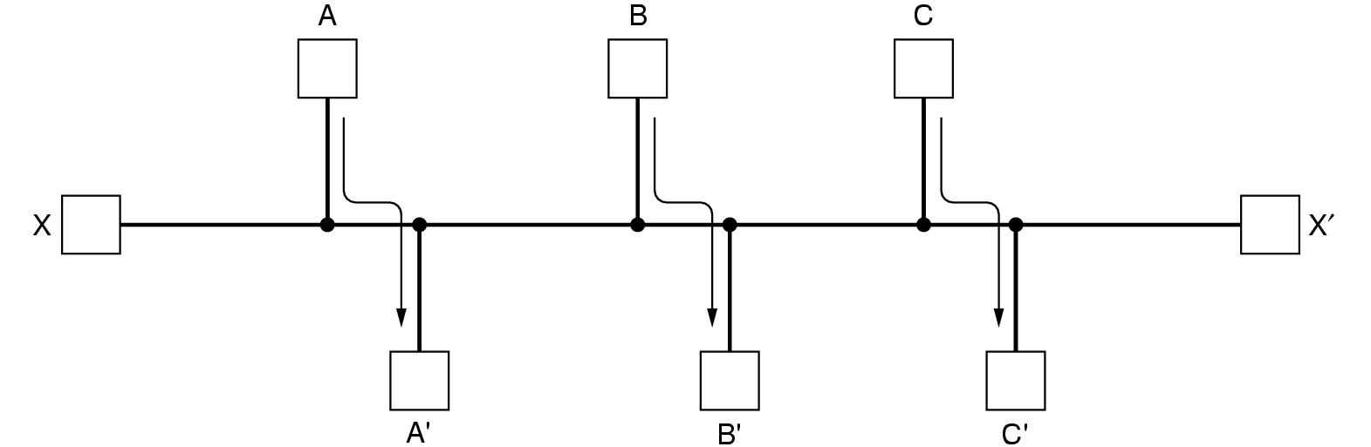

- There is enough traffic between A and A', between B and B', and between C and C' to saturate the horizontal links. To maximize the total flow, the X to X' traffic should be shut off altogether. Unfortunately, X and X' may not see it that way. Evidently, some compromise between global efficiency and fairness to individual connections is needed.

Category of algorithm
- Nonadaptive
- Adaptive
Nonadaptive algorithms do not base their routing decisions on measurements or estimates of the current traffic and topology. Instead, the choice of the route to use to get from I to J is computed in advance, off-line, and downloaded to the routers when the network is booted. This procedure is sometimes called static routing.
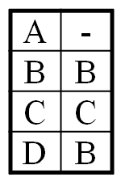

Adaptive algorithms, in contrast, change their routing decisions to reflect changes in the topology, and usually the traffic as well. This procedure is sometimes called dynamic routing

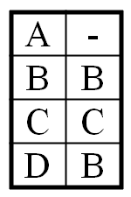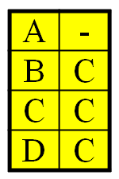

Various Routing Algorithms

- The Optimality Principle
- Shortest Path Routing
- Flooding
- Distance Vector Routing
- Link State Routing
- Hierarchical Routing
- Broadcast Routing

The Optimality Principle: if router J is on the optimal path from router I to router K, then the optimal path from J to K also falls along the same route.

J

The set of optimal routes from all sources to a given destination form a tree rooted at the destination. Such a tree is called a sink tree.
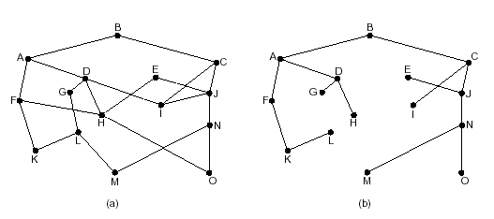
Figure (a) A subnet. (b) A sink tree for router B

- Note: A sink tree is not necessarily unique; other trees with the same path lengths may exist.
- The goal of all routing algorithms is to discover and use the sink trees for all routers.

- Explain in detail about Shortest Path Routing
- A technique to study routing algorithms: The idea is to build a graph of the subnet, with each node of the graph representing a router and each arc of the graph representing a communication line (often called a link).
- To choose a route between a given pair of routers, the algorithm just finds the shortest path between them on the graph.
- One way of measuring path length is the number of hops. Another metric is the geographic distance in kilometers . Many other metrics are also possible. For example, each arc could be labeled with the mean queuing and transmission delay for some standard test packet as determined by hourly test runs.
- In the general case, the labels on the arcs could be computed as a function of the distance, bandwidth, average traffic, communication cost, mean queue length, measured delay, and other factors. By changing the weighting function, the algorithm would then compute the ''shortest'' path measured according to any one of a number of criteria or to a combination of criteria.

- Explain in detail about Dijkstra algorithm
- Each node is labeled (in parentheses) with its distance from the source node along the best known path. Initially, no paths are known, so all nodes are labeled with infinity.
- As the algorithm proceeds and paths are found, the labels may change, reflecting better paths.
- A label may be either tentative or permanent. Initially, all labels are tentative. When it is discovered that a label represents the shortest possible path from the source to that node, it is made permanent and never changed thereafter.
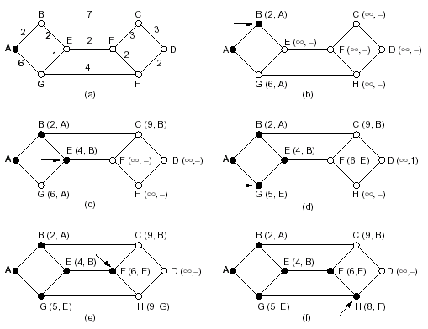
Figure. The first five steps used in computing the shortest path from A to D. The arrows indicate the working node
The shortest path from A to D is: ABEFHD
- Explain in detail Flooding algorithm
- Every incoming packet is sent out on every outgoing line except the one it arrived on.
- Flooding obviously generates vast numbers of duplicate packets, in fact, an infinite number unless some measures are taken to damp the process.
  - One such measure is to have a hop counter contained in the header of each packet, which is decremented at each hop, with the packet being discarded when the counter reaches zero.
  - An alternative technique for damming the flood is to keep track of which packets have been flooded, to avoid sending them out a second time.
- A variation of flooding that is slightly more practical is selective flooding.In this algorithm the routers do not send every incoming packet out on every line, only on those lines that are going approximately in the right direction.
- Applications of flooding algorithm:
    - military applications
    - distributed database applications
    - wireless networks
    - as a metric against which other routing algorithms can be compared

- Explain in detail about Distance Vector Routing

- A dynamic routing algorithm
- Distance vector routing algorithms operate by having each router maintain a table (i.e, a vector) giving the best known distance to each destination and which line to use to get there. These tables are updated by exchanging information with the neighbors. (also named the distributed Bellman-Ford routing algorithm and the Ford-Fulkerson algorithm)
- Table content: In distance vector routing, each router maintains a routing table indexed by, and containing one entry for, each router in the subnet. This entry contains two parts: the preferred outgoing line to use for that destination and an estimate of the time or distance to that destination.
- Table updating method:
  - Assume that the router knows the delay to each of its neighbors. Once every T msec each router sends to each neighbor a list of its estimated delays to each destination. It also receives a similar list from each neighbor.
  - Imagine that one of these tables has just come in from neighbor X, with X_{i} being X's estimate of how long it takes to get to router i. If the router knows that the delay to X is m msec, it also knows that it can reach router i via X in X_{i} + m msec.
  - By performing this calculation for each neighbor, a router can find out which estimate seems the best and use that estimate and the corresponding line in its new routing table. Note that the old routing table is not used in the calculation.

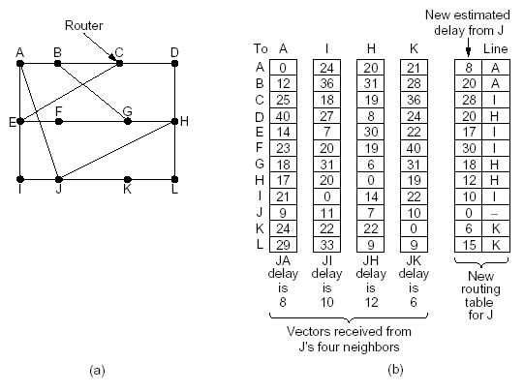
Part (a) shows a subnet. The first four columns of part (b) show the delay vectors received from the neighbors of router J. Suppose that J has measured or estimated its delay to its neighbors, A, I, H, and K as 8, 10, 12, and 6 msec, respectively.
- Explain in detail about Link State Routing

- A dynamic routing algorithm
- The idea behind link state routing can be stated as five parts. Each router must do the following:
  - Discover its neighbors and learn their network addresses.
  - Measure the delay or cost to each of its neighbors.
  - Construct a packet telling all it has just learned.
  - Send this packet to all other routers.
  - Compute the shortest path to every other router.
- In effect, the complete topology and all delays are experimentally measured and distributed to every router. Then Dijkstra's algorithm can be run to find the shortest path to every other router.
Learning about the Neighbors
- It accomplishes this goal by sending a special HELLO packet on each point-to-point line. The router on the other end is expected to send back a reply telling who it is.
- These names must be globally unique because when a distant router later hears that three routers are all connected to F, it is essential that it can determine whether all three mean the same F.
Measuring Line Cost
- The most direct way to determine this delay is to send over the line a special ECHO packet that the other side is required to send back immediately.
- By measuring the round-trip time and dividing it by two, the sending router can get a reasonable estimate of the delay.
- For even better results, the test can be conducted several times, and the average used. Of course, this method implicitly assumes the delays are symmetric, which may not always be the case.
Building Link State Packets
- The packet starts with the identity of the sender, followed by a sequence number and age (to be described later), and a list of neighbors. For each neighbor, the delay to that neighbor is given.
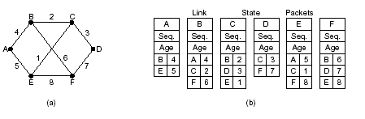 (a) A subnet. (b) The link state packets for this subnet
- Building the link state packets is easy. The hard part is determining when to build them.
  - One possibility is to build them periodically, that is, at regular intervals.
  - Another possibility is to build them when some significant event occurs, such as a line or neighbor going down or coming back up again or changing its properties appreciably.
Distributing the Link State Packets
- The basic distribution algorithm:The fundamental idea is to use flooding to distribute the link state packets.
- To keep the flood in check, each packet contains a sequence number that is incremented for each new packet sent. Routers keep track of all the (source router, sequence) pairs they see.
- When a new link state packet comes in, it is checked against the list of packets already seen.
  - If it is new, it is forwarded on all lines except the one it arrived on.
  - If it is a duplicate, it is discarded.
  - If a packet with a sequence number lower than the highest one seen so far ever arrives, it is rejected as being obsolete since the router has more recent data.
- First problem with this algorithm: if the sequence numbers wrap around, confusion will reign. The solution here is to use a 32-bit sequence number. With one link state packet per second, it would take 137 years to wrap around, so this possibility can be ignored.
- Second problem: if a router ever crashes, it will lose track of its sequence number. If it starts again at 0, the next packet will be rejected as a duplicate.
- Third problem :if a sequence number is ever corrupted and 65,540 is received instead of 4 (a 1-bit error), packets 5 through 65,540 will be rejected as obsolete, since the current sequence number is thought to be 65,540.
- The solution to all these problems is to include the age of each packet after the sequence number and decrement it once per second. When the age hits zero, the information from that router is discarded.

Computing the New Routes
- Once a router has accumulated a full set of link state packets, it can construct the entire subnet graph because every link is represented.
- Now Dijkstra's algorithm can be run locally to construct the shortest path to all possible destinations.

- Explain in detail about Hierarchical Routing
- The routers are divided into what we will call regions, with each router knowing all the details about how to route packets to destinations within its own region, but knowing nothing about the internal structure of other regions.
- For huge networks, a two-level hierarchy may be insufficient; it may be necessary to group the regions into clusters, the clusters into zones, the zones into groups, and so on, until we run out of names for aggregations.
region
region
region
region
region
region
region
region
region
region
region
region
cluster
cluster
cluster
cluster
zone
zone
- The full routing table for router 1A has 17 entries, as shown in (b).
- When routing is done hierarchically, as in (c), there are entries for all the local routers as before, but all other regions have been condensed into a single router, so all traffic for region 2 goes via the 1B -2A line, but the rest of the remote traffic goes via the 1C -3B line.
- Hierarchical routing has reduced the table from 17 to 7 entries.

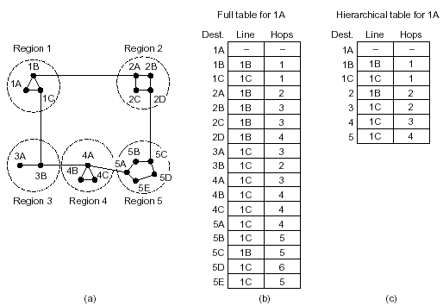

- Unfortunately, these gains in space are not free. There is a penalty to be paid, and this penalty is in the form of increased path length
- For example, the best route from 1A to 5C is via region 2, but with hierarchical routing all traffic to region 5 goes via region 3, because that is better for most destinations in region 5
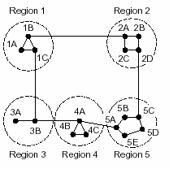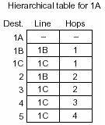

- Explain in detail about Broadcast Routing
Sending a packet to all destinations simultaneously is called broadcasting.
- The source simply sends a distinct packet to each destination. Not only is the method wasteful of bandwidth, but it also requires the source to have a complete list of all destinations.
- Flooding: The problem with flooding as a broadcast technique is that it generates too many packets and consumes too much bandwidth.
- Multi-destination routing.
- If this method is used, each packet contains either a list of destinations or a bit map indicating the desired destinations. When a packet arrives at a router, the router checks all the destinations to determine the set of output lines that will be needed. (An output line is needed if it is the best route to at least one of the destinations.)
- The router generates a new copy of the packet for each output line to be used and includes in each packet only those destinations that are to use the line. In effect, the destination set is partitioned among the output lines.
- After a sufficient number of hops, each packet will carry only one destination and can be treated as a normal packet.
- A fourth broadcast algorithm makes explicit use of the sink tree for the router initiating the broadcast—or any other convenient spanning tree for that matter.
- A spanning tree is a subset of the subnet that includes all the routers but contains no loops.
- If each router knows which of its lines belong to the spanning tree, it can copy an incoming broadcast packet onto all the spanning tree lines except the one it arrived on.
- Reverse path forwarding.
- When a broadcast packet arrives at a router, the router checks to see if the packet arrived on the line that is normally used for sending packets to the source of the broadcast.
  - If so, there is an excellent chance that the broadcast packet itself followed the best route from the router and is therefore the first copy to arrive at the router. This being the case, the router forwards copies of it onto all lines except the one it arrived on.
  - If, however, the broadcast packet arrived on a line other than the preferred one for reaching the source, the packet is discarded as a likely duplicate.

- Explain in detail about Congestion Control Algorithms and its approaches
Too many packets present in (a part of) the network causes packet delay and loss that degrades performance. This situation is called congestion.
Unless the network is well designed, it may experience a congestion collapse, in which performance plummets as the offered load increases beyond the capacity. This can happen because packets can be sufficiently delayed inside the network that they are no longer useful when they leave the network.

Approaches to Congestion Control
- To avoid congestion is to build a network that is well matched to the traffic that it carries. If there is a low-bandwidth link on the path along which most traffic is directed, congestion is likely. Sometimes resources can be added dynamically when there is serious congestion, for example, turning on spare routers or enabling lines that are normally used only as backups (to make the system fault tolerant) or purchasing bandwidth on the open market. More often, links and routers that are regularly heavily utilized are upgraded at the earliest opportunity. This is called network provisioning.
Traffic aware routing
- Routes can be tailored to traffic patterns that change during the day as network users wake and sleep in different time zones. For example, routes may be changed to shift traffic away from heavily used paths by changing the shortest path weights. Some local radio stations have helicopters flying around their cities to report on road congestion to make it possible for their mobile listeners to route their packets (cars) around hotspots. This is called traffic-aware routing. Splitting traffic across multiple paths is also helpful.
Admission control
- Sometimes it is not possible to increase capacity. The only way then to beat back the congestion is to decrease the load. In a virtual-circuit network, new connections can be refused if they would cause the network to become congested. This is called admission control.
Traffic Throttling
- At a finer granularity, when congestion is imminent the network can deliver feedback to the sources whose traffic flows are responsible for the problem. The network can request these sources to throttle their traffic, or it can slow down the traffic itself.
Load shedding
Two difficulties with this approach are how to identify the onset of congestion, and how to inform the source that needs to slow down.
- To tackle the first issue, routers can monitor the average load, queueing delay, or packet loss. In all cases, rising numbers indicate growing congestion.
- To tackle the second issue, routers must participate in a feedback loop with the sources. when all else fails, the network is forced to discard packets that it cannot deliver. The general name for this is load shedding.

- Explain about internetworking
An internetwork is often referred to as a network of networks because it is made up of lots of smaller networks. The nodes that interconnect the networks are called routers. They are also sometimes called gateways, but since this term has several other connotations, we restrict our usage to router. The internet protocol is the key tool used today to build scalable, heterogeneous internetwork.

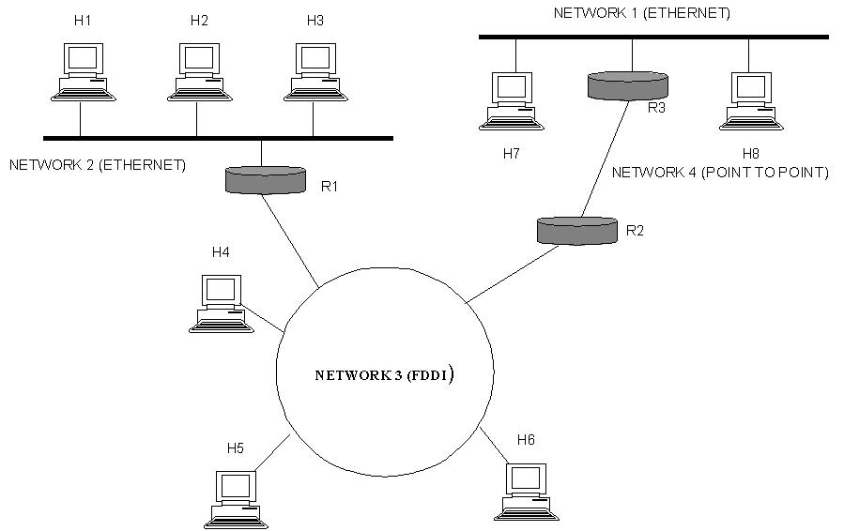

Tunneling
- If they are two geographically separate networks, which want to communicate with each other, they may deploy a dedicated line between or they have to pass their data through intermediate networks.
- Tunneling is a mechanism by which two or more same networks communicate with each other, by passing intermediate networking complexities. Tunneling is configured at both ends
A technique called tunneling. To send an IP packet to a host in the London office, a host in the Paris office constructs the packet containing an IPv6 address in London, and sends it to the multiprotocol router that connects the Paris IPv6 network to the IPv4 Internet. When this router gets the IPv6 packet, it encapsulates the packet with an IPv4 header addressed to the IPv4 side of the multiprotocol router that connects to the London IPv6 network. That is, the router puts a (IPv6) packet inside a (IPv4) packet. When this wrapped packet arrives, the London router removes the original IPv6 packet and sends it onward to the destination host.

Packet Fragmentation
- Most Ethernet segments have their maximum transmission unit (MTU) fixed to 1500 bytes. A data packet can have more or less packet length depending upon the application. Devices in the transit path also have their hardware and software capabilities which tell what amount of data that device can handle and what size of packet it can process.
- If the data packet size is less than or equal to the size of packet the transit network can handle, it is processed neutrally. If the packet is larger, it is broken into smaller pieces and then forwarded. This is called packet fragmentation. Each fragment contains the same destination and source address and routed through transit path easily. At the receiving end it is assembled again.
- If a packet with DF (don’t fragment) bit set to 1 comes to a router which can not handle the packet because of its length, the packet is dropped.
- When a packet is received by a router has its MF (more fragments) bit set to 1, the router then knows that it is a fragmented packet and parts of the original packet is on the way.
- If packet is fragmented too small, the overhead is increases. If the packet is fragmented too large, intermediate router may not be able to process it and it might get dropped.
- The alternative solution to the problem is to allow routers to break up packets into fragments, sending each fragment as a separate network layer packet
Transparent fragmentation is straightforward but has some problems. For one thing, the exit router must know when it has received all the pieces, so either a count field or an ‘‘end of packet’’ bit must be provided. Also, because all packets must exit via the same router so that they can be reassembled, the routes are constrained. By not allowing some fragments to follow one route to the ultimate destination and other fragments a disjoint route, some performance may be lost. More significant is the amount of work that the router may have to do. It may need to buffer the fragments as they arrive, and decide when to throw them away if not all of the fragments arrive. Some of this work may be wasteful, too, as the packet may pass through a series of small packet networks and need to be repeatedly fragmented and reassembled.

The Non fragmentation strategy is to refrain from recombining fragments at any intermediate routers. Once a packet has been fragmented, each fragment is treated as though it were an original packet. The routers pass the fragments, and reassembly is performed only at the destination host.The main advantage of nontransparent fragmentation is that it requires routers to do less work. IP works this way. A

Explain in detail about Internet Protocol Version 4 (IPv4)

Internet Protocol is one of the major protocols in the TCP/IP protocols suite. This protocol works at the network layer of the OSI model and at the Internet layer of the TCP/IP model. Thus this protocol has the responsibility of identifying hosts based upon their logical addresses and to route data among them over the underlying network
- IP provides a mechanism to uniquely identify hosts by an IP addressing scheme. IP uses best effort delivery, i.e. it does not guarantee that packets would be delivered to the destined host, but it will do its best to reach the destination. Internet Protocol version 4 uses 32-bit logical address.
- Internet Protocol being a layer-3 protocol (OSI) takes data Segments from layer-4 (Transport) and divides it into packets. IP packet encapsulates data unit received from above layer and add to its own header information.

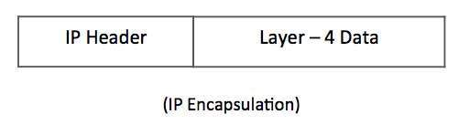
The encapsulated data is referred to as IP Payload. IP header contains all the necessary information to deliver the packet at the other end.
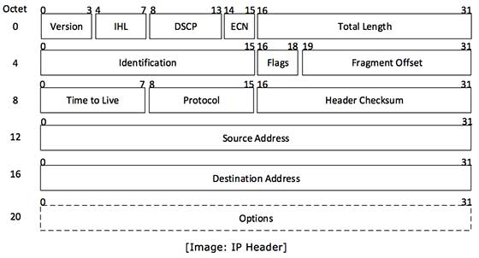
IP header includes many relevant information including Version Number, which, in this context, is 4. Other details are as follows:
- Version: Version no. of Internet Protocol used (e.g. IPv4).
- IHL: Internet Header Length; Length of entire IP header.
- DSCP: Differentiated Services Code Point; this is Type of Service.
- ECN: Explicit Congestion Notification; It carries information about the congestion seen in the route.
- Total Length: Length of entire IP Packet (including IP header and IP Payload).
- Identification: If IP packet is fragmented during the transmission, all the fragments contain same identification number. to identify original IP packet they belong to.
- Flags: As required by the network resources, if IP Packet is too large to handle, these ‘flags’ tells if they can be fragmented or not. In this 3-bit flag, the MSB is always set to ‘0’.
- Fragment Offset: This offset tells the exact position of the fragment in the original IP Packet.
- Time to Live: To avoid looping in the network, every packet is sent with some TTL value set, which tells the network how many routers (hops) this packet can cross. At each hop, its value is decremented by one and when the value reaches zero, the packet is discarded.
- Protocol: Tells the Network layer at the destination host, to which Protocol this packet belongs to, i.e. the next level Protocol. For example protocol number of ICMP is 1, TCP is 6 and UDP is 17.
- Header Checksum: This field is used to keep checksum value of entire header which is then used to check if the packet is received error-free.
- Source Address: 32-bit address of the Sender (or source) of the packet.
- Destination Address: 32-bit address of the Receiver (or destination) of the packet.
- Options: This is optional field, which is used if the value of IHL is greater than 5. These options may contain values for options such as Security, Record Route, Time Stamp, etc.

Discuss about Network Address Translation (NAT) definition

A NAT (Network Address Translation or Network Address Translator) is the virtualization of Internet Protocol (IP) addresses. NAT helps improve security and decrease the number of IP addresses an organization needs.
NAT gateways sit between two networks, the inside network and the outside network. Systems on the inside network are typically assigned IP addresses that cannot be routed to external networks (e.g., networks in the 10.0.0.0/8 block). A few externally valid IP addresses are assigned to the gateway. The gateway makes outbound traffic from an inside system appear to be coming from one of the valid external addresses. It takes incoming traffic aimed at a valid external address and sends it to the correct internal system. This helps ensure security, since each outgoing or incoming request must go through a translation process that also offers the opportunity to qualify or authenticate incoming streams and match them to outgoing requests, for example.
NAT conserves the number of globally valid IP addresses a company needs, and in combination with Classless Inter-Domain Routing (CIDR) has done a lot to extend the useful life of IPv4 as a resultFrom a local IP address to one global IP address statically;
- From a local IP address to any of a rotating pool of global IP addresses a company may have;
- From a local IP address plus a particular TCP port to a global IP address or one in a pool of ports;
- From a global IP address to any of a pool of local IP addresses on a round-robin basis.
A newer role for NAT focuses on translating IPv4 addresses to IPv6, and vice versa, to provide integration of IPv4 infrastructure and end-nodes into IPv6 environments, and allow IPv6 services to interact with IPv4 systems.
IP Address
- An IP is a 32-bit number comprised of a host number and a network prefix, both of which are used to uniquely identify each node within a network.
- To make these addresses more readable, they are broken up into 4 bytes, or octets, where any 2 bytes are separated by a period. This is commonly referred to as dotted decimal notation.
- The first part of an Internet address identifies the network on which the host resides, while the second part identifies the particular host on the given network. This creates the two-level addressing hierarchy.
- All hosts on a given network share the same network prefix but must have a unique host number. Similarly, any two hosts on different networks must have different network prefixes but may have the same host number.
Here is a simple example of an IP address: 192.168.1.1
  - An additional value, called a subnet mask, determines the boundary between the network and host components of an address.
  - Subnet masks are 32 bits long and are typically represented in dotted-decimal (such as 255.255.255.0) or the number of networking bits (such as /24). The networking bits in a mask must be contiguous and the host bits in the subnet mask must be contiguous. 255.0.255.0 is an invalid mask. A subnet mask is used to mask a portion of the IP address, so that TCP/IP can tell the difference between the network ID and the host ID. TCP/IP uses the subnet mask to determine whether the destination is on a local or remote network.
- Class A subnet mask 255.0.0.0
- Class B subnet mask 255.255.0.0
- Class C subnet mask 255.255.255.0
When dealing with IP addresses, the address is broken into two components:
- Network component Defines on what segment, in the network, a device is located
- Host component Defines the specific device on a particular network segment
The network number uniquely identifies a segment in the network and a host number uniquely identifies a device on a segment. The combination of these two numbers must be unique throughout the entire network.
IP addresses are divided in five class.
Class A addresses range from 1-126
Class B addresses range from 128-191
Class C addresses range from 192-223
Class D addresses range from 224-239
Class E addresses range from 240-254

0 is reserved and represents all IP addresses;
127 is a reserved address and is used for loop back tasting:
255 is a reserved address and is used for broadcasting purposes.
It is fairly easy to predict what address belongs to what class. Simply look at the first number in the dotted-decimal notation and see which range it falls into.
For example
- IP address 159.123.12.2 belongs to class B because 159 [First number] falls in range 128 - 191
- IP address 15.12.12.6 belongs to class A because 15 [First number] falls in range 1 - 126
- IP address 192.168.1.2 belongs to class C because 192 [First number] falls in range 192 - 223
- When you are dealing with IP addresses, two numbers are always reserved for each network number:
- The first address in the network represents the network's address, and the last address in the network represents the broadcast address for this network, called directed broadcast.
- When you look at IP itself, two IP addresses are reserved: 0.0.0.0 (the very first address), which represents all IP addresses, and 255.255.255.255 (the very last address), which is the local broadcast address.
- As to assigning addresses to devices, two general types of addresses can be used: public and private.

Public addresses
Public addresses are Class A, B, and C addresses that can be used to access devices in other public networks, such as the Internet.

Private Addresses
Within the range of addresses for Class A, B, and C addresses are some reserved addresses, commonly called private addresses. Anyone can use private addresses; however, this creates a problem if you want to access the Internet.
Class A: 10.0.0.0–10.255.255.255 (1 Class A network)
Class B: 172.16.0.0–172.31.255.255 (16 Class B networks)
Class C: 192.168.0.0–192.168.255.255 (256 Class C networks)
When calculating hosts' IP addresses, 2 IP addresses are decreased because they cannot be assigned to hosts, i.e. the first IP of a network is network number and the last IP is reserved for Broadcast IP.

Explain in detail about Internet Protocol v6 (IPv6)
IETF (Internet Engineering Task Force) has redesigned IP addresses to mitigate the drawbacks of IPv4. The new IP address is version 6 which is 128-bit address, by which every single inch of the earth can be given millions of IP addresses.
Today majority of devices running on Internet are using IPv4 and it is not possible to shift them to IPv6 in the coming days. There are mechanisms provided by IPv6, by which IPv4 and IPv6 can co-exist unless the Internet entirely shifts to IPv6:
- Dual IP Stack
- Tunneling (6to4 and 4to6)
- NAT Protocol Translation
- An IPv6 address is 4 times larger than IPv4, but surprisingly, the header of an IPv6 address is only 2 times larger than that of IPv4. IPv6 headers have one Fixed Header and zero or more Optional (Extension) Headers. All the necessary information that is essential for a router is kept in the Fixed Header. The Extension Header contains optional information that helps routers to understand how to handle a packet/flow.

Fixed Header
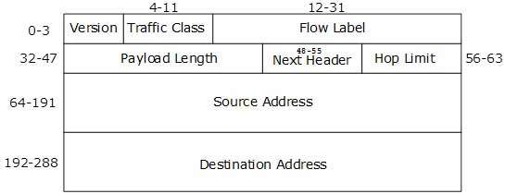
- IPv6 fixed header is 40 bytes long and contains the following information.
Field & Description
  - Version (4-bits): It represents the version of Internet Protocol, i.e. 0110
  - Traffic Class (8-bits): These 8 bits are divided into two parts. The most significant 6 bits are used for Type of Service to let the Router Known what services should be provided to this packet. The least significant 2 bits are used for Explicit Congestion Notification (ECN).
  - Flow Label (20-bits): This label is used to maintain the sequential flow of the packets belonging to a communication. The source labels the sequence to help the router identify that a particular packet belongs to a specific flow of information. This field helps avoid re-ordering of data packets. It is designed for streaming/real-time media.
  - Payload Length (16-bits): This field is used to tell the routers how much information a particular packet contains in its payload. Payload is composed of Extension Headers and Upper Layer data. With 16 bits, up to 65535 bytes can be indicated; but if the Extension Headers contain Hop-by-Hop Extension Header, then the payload may exceed 65535 bytes and this field is set to 0.
  - Next Header (8-bits): This field is used to indicate either the type of Extension Header, or if the Extension Header is not present then it indicates the Upper Layer PDU. The values for the type of Upper Layer PDU are same as IPv4’s.
Hop Limit (8-bits): This field is used to stop packet to loop in the network infinitely. This is same as TTL in IPv4. The value of Hop Limit field is decremented by 1 as it passes a link (router/hop). When the field reaches 0 the packet is discarded.
  - Source Address (128-bits): This field indicates the address of originator of the packet.
  - Destination Address (128-bits): This field provides the address of intended recipient of the packet.
- Internet Control Message Protocol (ICMP)
The operation of the Internet is monitored closely by the routers. When something unexpected occurs during packet processing at a router, the event is reported to the sender by the ICMP (Internet Control Message Protocol). ICMP is also used to test the Internet. About a dozen types of ICMP messages are defined. Each ICMP message type is carried encapsulated in an IP packet.
The Principle ICMP Message Type
- The DESTINATION UNREACHABLE message is used when the router cannot locate the destination or when a packet with the DF bit cannot be delivered because a ‘‘small-packet’’ network stands in the way.
- The TIME EXCEEDED message is sent when a packet is dropped because its TtL (Time to live) counter has reached zero. This event is a symptom that packets are looping, or that the counter values are being set too low.
- The PARAMETER PROBLEM message indicates that an illegal value has been detected in a header field. This problem indicates a bug in the sending host’s IP software or possibly in the software of a router transited.
- The SOURCE QUENCH message was long ago used to throttle hosts that were sending too many packets. When a host received this message, it was expected to slow down. It is rarely used anymore because when congestion occurs, these packets tend to add more fuel to the fire and it is unclear how to respond to them.
- The REDIRECT message is used when a router notices that a packet seems to be routed incorrectly. It is used by the router to tell the sending host to update to a better route.
- The ECHO and ECHO REPLY messages are sent by hosts to see if a given destination is reachable and currently alive. Upon receiving the ECHO message, the destination is expected to send back an ECHO REPLY message. These messages are used in the ping utility that checks if a host is up and on the Internet.
- The TIMESTAMP REQUEST and TIMESTAMP REPLY messages are similar, except that the arrival time of the message and the departure time of the reply are recorded in the reply. This facility can be used to measure network performance.
- The ROUTER ADVERTISEMENT and ROUTER SOLICITATION messages are used to let hosts find nearby routers. A host needs to learn the IP address of at least one router to be able to send packets off the local network.

Discuss about Address Resolution Protocol(ARP)
  - While communicating, a host needs Layer-2 (MAC) address of the destination machine which belongs to the same broadcast domain or network. A MAC address is physically burnt into the Network Interface Card (NIC) of a machine and it never changes.
  - On the other hand, IP address on the public domain is rarely changed. If the NIC is changed in case of some fault, the MAC address also changes. This way, for Layer-2 communication to take place, a mapping between the two is required.
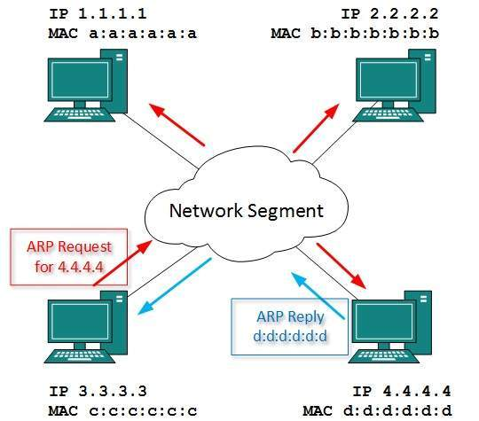
  - To know the MAC address of remote host on a broadcast domain, a computer wishing to initiate communication sends out an ARP broadcast message asking, “Who has this IP address?” Because it is a broadcast, all hosts on the network segment (broadcast domain) receive this packet and process it. ARP packet contains the IP address of destination host, the sending host wishes to talk to. When a host receives an ARP packet destined to it, it replies back with its own MAC address.
  - Once the host gets destination MAC address, it can communicate with remote host using Layer-2 link protocol. This MAC to IP mapping is saved into ARP cache of both sending and receiving hosts. Next time, if they require to communicate, they can directly refer to their respective ARP cache.
  - Reverse ARP is a mechanism where host knows the MAC address of remote host but requires to know IP address to communicate.

Explain about OSPF (Open Shortest Path First)
OSPF Open Shortest Path First is a link-state routing protocol that was developed in 1991.OSPF was developed as a replacement for the distance vector routing protocol RIP. It operates as a classless routing protocol that uses the concept of areas for network scalability. OSPF's major advantages over RIP are its fast convergence and its scalability to much larger network implementations. OSPF has a default administrative distance of 110. As a classless routing protocol, it does not use a Transport layer protocol, as OSPF packets are sent directly over IP.
  - Hello: are used to establish and maintain adjacency with other OSPF routers. They are also used to elect the Designated Router (DR) and Backup Designated Router (BDR) on multi access networks (like Ethernet or Frame Relay).
  - Database Description (DBD or DD): contains an abbreviated list of the sending router’s link-state database and is used by receiving routers to check against the local link-state database
  - Link-State Request (LSR): used by receiving routers to request more information about any entry in the DBD
  - Link-State Update (LSU): used to reply to LSRs as well as to announce new information. LSUs contain seven different types of Link-State Advertisements (LSAs)
  - Link-State Acknowledgement (LSAck): sent to confirm receipt of an LSU message

OSPF Hello Packets
The OSPF Hello packet is used to establish neighbor adjacencies. By default, OSPF Hello packets are sent :
    - Every 10 seconds on multi-access and point-to-point segments
    - Every 30 seconds on non-broadcast multi-access (NBMA) segments (Frame Relay, X.25, ATM).

OSPF Dead Intervals
OSPF dead interval is measured as the period of time an OSPF router will wait before terminating adjacency with a neighbor. The Dead interval is four times the Hello interval, by default.
    - For multi-access and point-to-point segments, this period is 40 seconds.
    - For NBMA networks, the Dead interval is 120 seconds.
For routers to become adjacent, their Hello interval, Dead interval, Network types and subnet masks must match.

OSPF Router IDs
The OSPF router ID is used to exclusively identify each router in the OSPF routing domain. Cisco routers derive the router ID based on three criteria and with the following preference:
    - the Use of the IP address configured with the OSPF router ID command.
    - If the router ID is not configured, the router chooses highest IP address of any of its loopback interfaces.
    - If no loopback interfaces are configured, the router chooses highest active IP address of any of its physical interfaces.
OSPF Area IDs
The area ID refers to the OSPF network domain area. An OSPF area is a group of routers that share link-state information. All OSPF routers in the same domain area must have the same link-state information - received from neighbours - in their link-state databases.
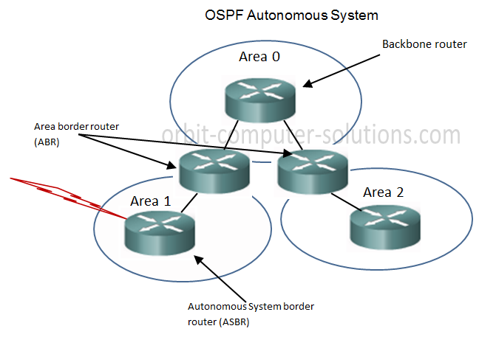
Open Shortest Path First (OSPF) is a popular routing protocol for IP networks for several key reasons:-
  - It is classless,
  - Offers full CIDR and VLSM support,
  - It scales well, converges quickly, and guarantees loop free routing.
  - It also supports address summarization and the tagging of external routes, similar to EIGRP (Enhanced Interior Gateway Routing Protocol).
OSPF uses a large, dimensionless metric on every link - which can also be referred to as "cost - , with a maximum value of 65,535. In those protocols, each router updates the total metric as it passes the route on to the next router. However, in OSPF, the routers distribute the individual link costs to one another. The maximum cost for an individual link, then, is 65,535. Any given path through an OSPF network can include many high-cost links, but still be usable. This is quite different from RIP, for example, where a few high-cost links along a path can make the entire path unusable.
- Discuss about BGP (Border Gateway Protocol)
- BGP is a complex, advanced distance Exterior Gateway Protocol (EGP), BGP exchange routing information between Autonomous Systems (ASs).
- Unlike Interior routing protocols such as RIP, EIGRP, and OSPF that run inside a company’s network, BGP uses a different basic algorithm for building a loop-free topology than any of the above mentioned protocols.
- BGP is especially used for exchanging routing information between all of the major Internet Service Providers (ISPs), as well between larger client sites and their respective ISPs. And, in some large enterprise networks, BGP is used to interconnect different geographical or administrative regions.
- BGP is Primarily used to support the complexity of the public Internet,CISCO has added several clever and useful features to its BGP implementation (BGP 4). Some of the primary attributes of BGP is the use of pieces of information about a known route, where it came from, and how to reach it, A BGP router will also generate an error message if it receives a route that is missing these are mandatory attributes.
Clients/ Corporate Networks being connected by BGP
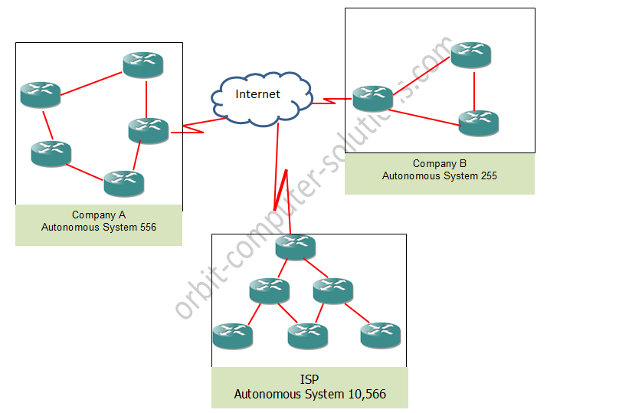
Types of BGP
There are different terms used when describing BGP. these including:
- 1.Internal BGP (iBGP) operates inside an autonomous System (AS)
- External BGP (eBGP), which is also known as an interdomain routing protocol, operates outside an AS and connects one AS to another. These terms are just used to describe the same protocol just the area of operation is what differs.
Autonomous Systems (AS)
An autonomous system can be a company, ISP or an entire corporate network comprised of multiple locations connecting to the network. Each autonomous System (AS) uses BGP to advertise routes in its network that need to be visible outside of the network; it also uses BGP to learn about the reachability and routes by listening to advertisement announcements from other autonomous systems. Each of these enterprise network, commercial enterprise or ISP must be identified by an autonomous system number (ASN). This number allows a hierarchy to be maintained when sharing route information.
There are 65,535 (from 0to 65,535) available autonomous system numbers that can be assigned. BGP assigns 64,512 - 65,534 ASNs to be private. Being private means this ASN connect to only one other ASN (sometimes multiple ASN) and these ASNs can’t cause loop by themselves.
- Explain about Multicast Routing
Some applications, such as a multiplayer game or live video of a sports event streamed to many viewing locations, send packets to multiple receivers. Unless the group is very small, sending a distinct packet to each receiver is expensive. On the other hand, broadcasting a packet is wasteful if the group consists of, say,
1000 machines on a million-node network, so that most receivers are not interested in the message (or worse yet, they are definitely interested but are not supposed to see it). Thus, we need a way to send messages to well-defined groups that are numerically large in size but small compared to the network as a whole.
Sending a message to such a group is called multicasting, and the routing algorithm used is called multicast routing. All multicasting schemes require some way to create and destroy groups and to identify which routers are members of a group. How these tasks are accomplished is not of concern to the routing algorithm.
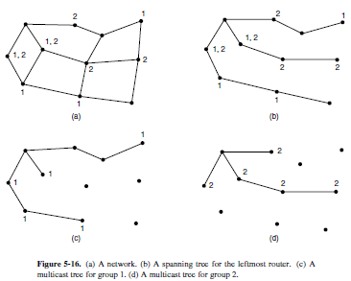
has n groups, each with an average of m nodes. At each router and for each group, m pruned spanning trees must be stored, for a total of mn trees. For example, Fig. 5-16(c) gives the spanning tree for the leftmost router to send to group 1. The spanning tree for the rightmost router to send to group 1 (not shown) will look quite different, as packets will head directly for group members rather than via the left side of the graph. This in turn means that routers must forward packets destined to group 1 in different directions depending on which node is sending
to the group. When many large groups with many senders exist, considerable storage is needed to store all the trees.
An alternative design uses core-based trees to compute a single spanning tree for the group (Ballardie et al., 1993). All of the routers agree on a root (called the core or rendezvous point) and build the tree by sending a packet from each member to the root. The tree is the union of the paths traced by these packets. Fig. 5-17(a) shows a core-based tree for group 1. To send to this group, a sender sends a packet to the core. When the packet reaches the core, it is forwarded down the tree. This is shown in Fig. 5-17(b) for the sender on the ighthand side of the network. As a performance optimization, packets destined for the group do not need to reach the core before they are multicast. As soon as a packet reaches the tree, it can be forwarded up toward the root, as well as down all the other branches.
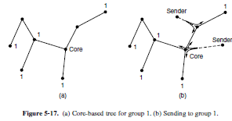

Having a shared tree is not optimal for all sources. For example, in Fig. 5- 17(b), the packet from the sender on the righthand side reaches the top-right group member via the core in three hops, instead of directly. The inefficiency depends on where the core and senders are located, but often it is reasonable when the core is in the middle of the senders. When there is only a single sender, as in a video that is streamed to a group, using the sender as the core is optimal. Also of note is that shared trees can be a major savings in storage costs, messages
sent, and computation. Each router has to keep only one tree per group, instead of m trees. Further, routers that are not part of the tree do no work at all to support the group. For this reason, shared tree approaches like core-based trees are used for multicasting to sparse groups in the Internet as part of popular protocols
such as PIM (Protocol Independent Multicast)
- Explain about the internetworking routing

Routing through an internet poses the same basic problem as routing within a single network, but with some added complications. To start, the networks may internally use different routing algorithms. For example, one network may use link state routing and another distance vector routing. Since link state algorithms need to know the topology but distance vector algorithms do not, this difference alone would make it unclear how to find the shortest paths across the internet.
Networks run by different operators lead to bigger problems. First, the operators may have different ideas about what is a good path through the network. One operator may want the route with the least delay, while another may want the most inexpensive route. This will lead the operators to use different quantities to
set the shortest-path costs (e.g., milliseconds of delay vs. monetary cost). The weights will not be comparable across networks, so shortest paths on the internet will not be well defined. Worse yet, one operator may not want another operator to even know the details of the paths in its network, perhaps because the weights and paths may reflect sensitive information (such as the monetary cost) that represents a competitive business advantage. Finally, the internet may be much larger than any of the networks that comprise it. It may therefore require routing algorithms that scale well by using a hierarchy, even if none of the individual networks need to use a hierarchy.
All of these considerations lead to a two-level routing algorithm. Within each network, an intradomain or interior gateway protocol is used for routing. (‘‘Gateway’’ is an older term for ‘‘router.’’) It might be a link state protocol of the kind we have already described. Across the networks that make up the internet, an interdomain or exterior gateway protocol is used. The networks may all use different intradomain protocols, but they must use the same interdomain protocol.
In the Internet, the interdomain routing protocol is called BGP (Border Gateway Protocol). We will describe it in the next section. There is one more important term to introduce. Since each network is operated
independently of all the others, it is often referred to as an AS (Autonomous System). A good mental model for an AS is an ISP network. In fact, an ISP network may be comprised of more than one AS, if it is managed, or, has been acquired, as multiple networks. But the difference is usually not significant. The two levels are usually not strictly hierarchical, as highly suboptimal paths might result if a large international network and a small regional network were both abstracted to be a single network. However, relatively little information about routes within the networks is exposed to find routes across the internetwork. This helps to address all of the complications. It improves scaling and lets operators freely select routes within their own networks using a protocol of their choosing.
It also does not require weights to be compared across networks or expose sensitive information outside of networks. However, we have said little so far about how the routes across the networks of the internet are determined. In the Internet, a large determining factor is the business arrangements between ISPs. Each ISP may charge or receive money from the other ISPs for carrying traffic. Another factor is that if internetwork routing requires crossing international boundaries, various laws may suddenly come into play, such as Sweden’s strict privacy laws about exporting personal data about Swedish citizens from Sweden. All of these nontechnical factors are wrapped up in the concept of a routing policy that governs the way autonomous networks select the routes that they use. We will return to routing policies .

